ST. THOMAS ORTHODOX CATHEDRAL, DUBAI, U.A.E
TIME LINE
- 2nd Dec 1968 – Formation of St. Thomas Orthodox Association presided by Bahrain Vicar Rev.Fr. K.K Punnoose (Late H.G Stephanos Mar Thevodosios)
- 1969 – First Metropolitan to visit Dubai H.G Thomas Mar Thimothios (H.H Marthoma Didimos I)
- 1972 – Request to Dubai Ruler H.H Sheikh Rashid Bin Saeed Al Maktoum for land to construct church by H.G Mathews Mar Coorlios (Late H.H Marthoma Mathews II)
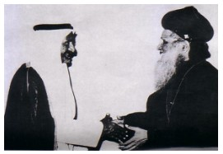
- 25th Apr 1972 – Plot No.B21, Zabeel East Area allocated to Church
- 1975 – Church affiliated to Delhi Diocese
- 1976 – Consecration of First Church by Late H.G Joseph Mar Pachomios
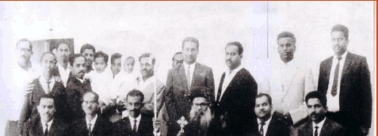
- 1976 – First Diocesan Metropolitan Late H.G Dr. Paulose Mar Gregorios took charge
- 5th Jul 1991 – Foundation stone laid for 2nd Church by Late H.G Dr. Paulose Mar Gregorios
- 1991 – Asst. Diocesan Metropolitan Late H.G Job Mar Philoxenos took charge
- 12th Jun 1992 – Consecration of Second Church by Late H.H Baselios Marthoma Mathews II assisted by Late H.G Dr. Paulose Mar Gregorios, Late H.G Stephanos Mar Thevodosios, H.G Kurakose Mar Clemis and Late H.G Job Mar Philoxenos
- 24 Nov 1996 – H.G Dr. Paulose Mar Gregorios enters heavenly abode
- 1999 – New Office Complex Inaugurated by Late H.H Baselios Marthoma Mathews II
- 26 Dec 2002 – Second Diocesan Metropolitan Late H.G Job Mar Philoxenos took charge
- Oct 2003 – Church elevated to “Great Church” by Late H.H Baselios Marthoma Mathews II
- 22nd Dec 2006 – Consecration of Third Church by H.H Baselios Marthoma Didimos I assisted by H.G Kurakose Mar Clemis and H.G Geevarghese Mar Coorilose
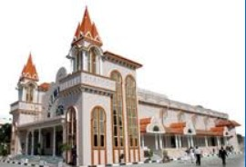
- 22nd Dec 2006 – Church elevated to “Cathedral” by H.H Baselios Marthoma Didimos I
- 20 Nov 2011 – H.G Job Mar Philoxenos enters heavenly abode
- 27 Jan 2012 – Catholicos H.H Baselios Marthoma Paulose II visit Cathedral
- 07 Oct 2012 – Third Diocesan Metropolitan H.G Dr. Yuhanon Mar Demetrios took charge
- 22 Nov 2013 – New Parish Hall & Community Hall Inaugurated by H.G Dr. Yuhanon Mar Demetrios assisted by H.G Dr. Yuhanon Mar Milithios.
